KNN -> slow algorithm hai ya lazy algo hai

It is extremely slow algo hai while doing Prediction & probably sbhse slow ML algo hai

Yeah prediction ka

Yeah Training ke time kuch krta hie nahi hai

Saare ke saare training points ko Ram Mai store krdeta hai

Time Complexity of KNN

O(nd)

n => number of rows

d = > dimensions

KD – Tree

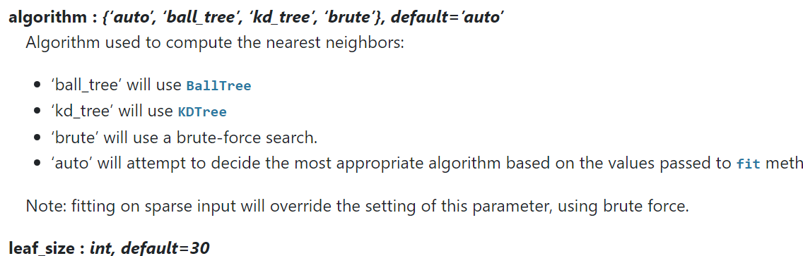

Yeah jo hai yeah Time Complexity ko Reduce krdeta hai to o(dlogn)

k-dimensional tree

Kd tree mai

Binary Search tree banate hai

**We use KD Tree When the dimensionality is 15 to 20**

**We Ball Tree when there is a dimensionality of 20+**